

Choir Church Choral Director



Application Pack 2
Job Description 8
Application Form 14
Church of England Confidential Declaration Form 16



Welcome from The Dean
The Very Reverend Peter Howell-Jones

Thank you for your interest in the position of a Choir Church Choral Director. This collaborative project is a direct response to the Diocesan Strategy Vision 2026 and seeks to build on the strong musical tradition here at Blackburn Cathedral and indeed across the Diocese.

As we prepare to work differently following the challenges of COVID-19 we are seeking energetic, faithful and innovative Choir Church Choral Directors with the experience, skills and flair to contribute to the delivery of this inspiring project for the benefit of all across the Diocese.

We are working towards being a Cathedral that has values rooted in the person and life of Jesus Christ and in the community that he builds which we summarise as: proclamation, joy, love and self-giving service.

Our website www.blackburncathedral.com will provide you with a glimpse of who we are as a community. If you would like further information, please contact Dr Rebekah Okpoti, our Choir Church Coordinator, on 0751 622 4815.

Once again, thank you for your interest.

With every blessing
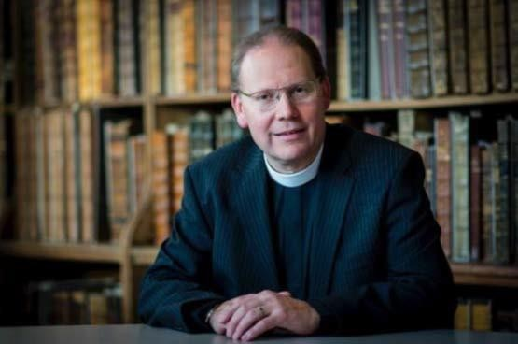
The Very Reverend Peter Howell-Jones
Dean of Blackburn

Background Information
Blackburn Cathedral is one of England’s newest cathedrals, yet it is one of the country’s oldest places of Christian worship. Blackburn Cathedral is a living community of prayer and worship, a centre of excellence in Church Music, education and community engagement and plays a key role as the Mother Church of the Diocese of Blackburn serving the Christian and wider community across the whole of Lancashire. It is also the most prominent of Blackburn’s heritage assets and tourist attractions, and a key cultural venue for Blackburn and the wider county of Lancashire.

This appointment comes at a strategic moment in the Cathedral’s life as Chapter considers its long- term strategic plan as we emerge from the challenges of the last few years and prepare to reignite delivery of our strategic plan. Blackburn Cathedral is set in a multi-faith urban context which has recently undergone significant renewal and development. The creation of a new Cathedral Close with a mix of spaces has provided a greater sense of place and focus within the town, including the adjoining Cathedral Square which provides a gathering place and a location for numerous public events throughout the year.

Blackburn is an increasingly diverse town, with positive and creative partnerships. The Cathedral sees itself as a significant partner in the life of the town and is seeking to develop partnerships further during the next few years, positioning itself as a Cathedral for the whole borough and indeed the County.

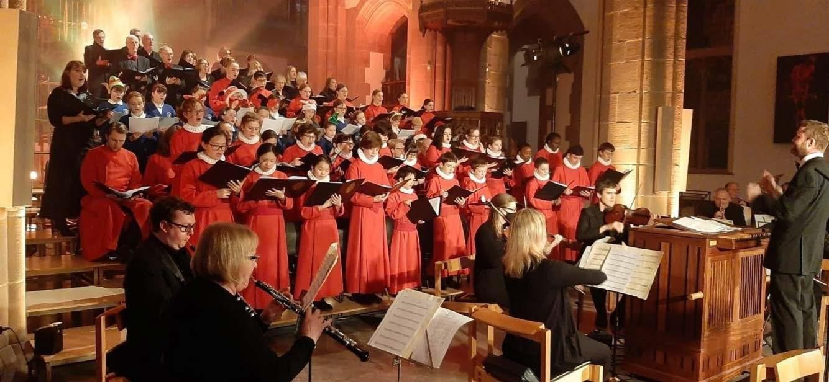
Vision, Purpose and Values

The Cathedral’s Vision and Strategic Plan is very closely aligned to the Diocesan Vision 2026: Healthy Churches Transforming Communities. The impact of Vision 2026 is evident in the growing ownership of the Vision themes, especially church planting, across the diocese. The diocesan target of planting 200 new local congregations is established with at least 100 congregations planted. Information about Vision 2026 can be found here.

Choir Church is an expression of this church planting strategy and is designed to be a catalyst for mission and growth for those churches whose tradition is central Anglican or Anglo-Catholic.

Choir Church will build partnerships between parishes, schools and families in order to plant new midweek congregations built around the Eucharist, using the Anglican choral tradition with an emphasis on social action to make new disciples of Jesus Christ.


“This is a fantastic initiative; we are delighted to be pioneering Choir Church in our Diocese on a scale never before attempted. With our Choir Church Project we aim to connect home, church and school in a fresh approach to outreach; providing opportunities in places where they may not be available otherwise.”
The Right Reverend Philip North, Bishop of Blackburn

Inspiring Children and Young People

Through Vision 2026, the diocese is pursuing a step change in work with children and young people. This is a strategic priority under Vision 2026 with a target of encouraging established and new opportunities for young people to come together in community and experience faith and a sense of belonging.

The Diocese has a strong tradition in this area. The work of our Diocesan Board of Education supports ministry to children and young people with effective resource and training. We have recently launched Learning Communities to foster this work and are rolling out Youthscape’s Launchpad programme.

The Diocese of Blackburn has a strong and thriving family of church schools, and our school leaders are committed to the wider mission of the Church. These relationships provide a basis for Choir Church.

Planting Congregations

By planting new congregations using music and social justice, we are pioneering a new approach to evangelism on a Diocesan scale for the first time. Our approach takes its learning from three individual parishes in London where Choir Church has been planted successfully, with impetus given by the Gregory Centre for Church Multiplication.

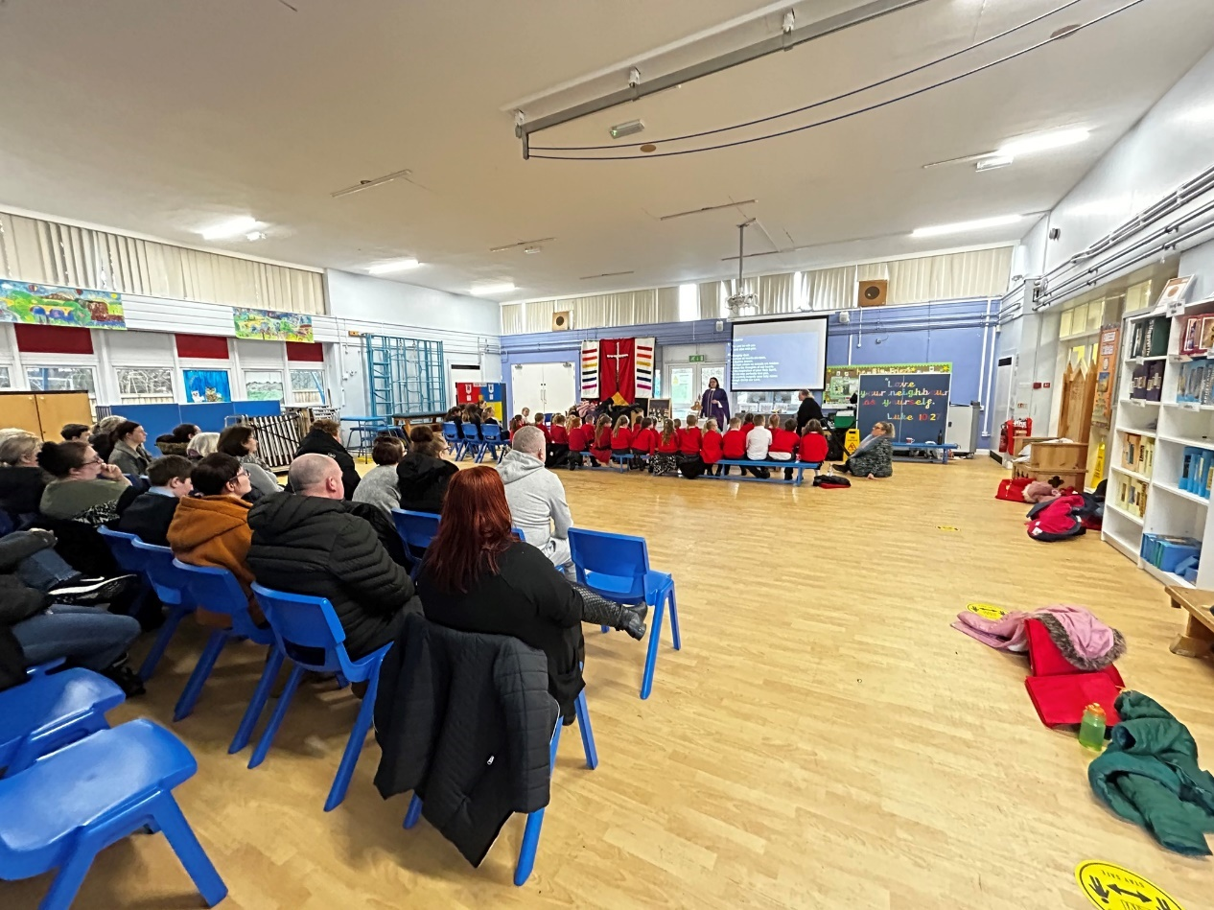

Choir Church
Our vision is to show and tell the good news of Jesus Christ by
- deepening our life of prayer through active discipleship, grounded in the sacraments
- growing and planting congregations, in which new people encounter Jesus
- organising for justice: being a church which is of and for the poorest

What is Choir Church?
Choir Church supports children and their families in growing their faith.
Choir Church is a model for planting new local congregations, built around children’s choirs in schools, led in partnership with local churches. Children receive high-quality singing tuition in their classes as part of their school day, have access to an after-school choir club, and meet at least monthly for a Eucharist in school, to which parents, teachers, and the wider community are able to join together in worship.

Choir Church has four elements:
  - Local school Choir Church builds a new congregation around a children’s choir based in a school
  - Eucharist A children’s choir sings in a Eucharist which is open to all – parents, teachers, and neighbours, including a ‘planting team’ of existing worshippers
  - Musical excellence Children learn a wide range of liturgical music, grounded in the Anglican choral tradition, equipping them musically for worship and life
  - Social justice The congregation is built and developed using the practices of community organising, so it can work with its neighbours to act on Jesus’ command to challenge injustice

Choir Church is being established in schools across the Diocese of Blackburn as part Vision 2026, with support from the Church Commissioners’ Innovation Fund, the Diocesan Board for Education, and the Diocesan Board for Finance. Choir Church is a partnership between a parish school, and church. Other partners who will offer support include Blackburn Cathedral and the Choir Church Foundation.
More information on Choir Church can be found on www.choirchurch.com.

“Music is a powerful evangelistic tool for the church, and generations of families have come to faith
through their children singing in choirs. Choir Church is bold about putting singing, sacrament and
justice at the heart of turning hearts and minds to Jesus.”
Tom Daggett Choir Church Foundation

Job Description
Choir Church Choral Director
We are looking to recruit a faithful and experienced choir and singing trainer to join the Choir Church team. The Choral Director will embed excellent choral singing in the school as part of a network of musicians, and work with the Vicar and Head Teacher to prepare the choir to lead monthly acts of worship as part of a new congregation. Choir Church is part of an innovative project across Lancashire, with the support of Blackburn Cathedral and Blackburn Diocese.
Start date: Ongoing
Working day: Between 1-3 days per week (days and number of days negotiable)

Working commitment: Weekly classroom singing with each year group, after- school choir rehearsing weekly, meeting at least monthly for worship; team meetings and administration.
Total commitment between 44 -132 days per year

Salary: between £7,000 PA, up to £21000 PA dependent on how many days per week. Payable by monthly invoice as a self-employed musician.

Line Management: Choir Church Coordinator

Safer Recruitment: Enhanced DBS (Child workforce)
Deadline: Ongoing open application period

Interview: Ongoing



Job Overview

The Choral Director will work with the Parish Priest and Head Teacher to plant a new local congregation using the Choir Church model and to do so by working in close partnership with the Diocese of Blackburn, Blackburn Cathedral and local parishes through a Choir Church Learning Community. The Choral Director will teach music designed to share the Christian faith, and they will nurture relationships with children and their families.
We are looking for someone who can:
- Visit partner schools to lead weekly timetabled choral singing sessions
- Direct an after-school choir at the partner school, which will rehearse weekly and participate in (at least) monthly midweek school-based Eucharistic worship
- Follow a curriculum, and select appropriate repertoire for musical worship
- Prepare children for an annual Choir Church festival using the prepared music and curriculum
- Develop good relationships with children, parents, teachers and the wider community
- Encourage school teachers in their own leadership of singing
- Encourage children and their families in their journey of faith
- Support the Christian ethos of our partner schools
- Help to share the Gospel of Jesus Christ
We are looking for an experienced choral leader who can deliver high-quality singing for different year groups, as well as launch and lead an after-school choir, which will be led collaboratively with the Parish Priest and a planting community, including parent volunteers. The function of the choir will be to provide music for monthly acts of worship in school, as well as pursue enrichment and performance opportunities further afield, and to connect with other community groups.
The weekly after-school choir will include 45 minutes of rehearsal, some interactive teaching to prepare children for worship, and games and refreshments. We are looking for someone who can balance high musical standards with fun and informality, in order to create a culture of ‘happy excellence’.

Responsibilities

Musical Leadership
  - 30 minutes of classroom singing per week for Years 1-6, based on the curriculum provided by the cathedral
  - Plan the monthly midweek Eucharist services using the music and themes for worship
  - Recruit for and lead an after-school choir
  - Lead the music in a monthly act of worship in school, and 3 Sunday mornings per academic year (agreed a term in advance)

In order to achieve this, you will have the following support:
  - Strong working relationship and connections between the school and church.
  - The Vicar, a teacher, and volunteers to support the children’s learning in the after-school choir, who are part of a planting community
  - Musical resources, support and supervision from the Choir Church Coordinator based at Blackburn Cathedral and the Choir Church Foundation
  - Ability to connect with other musicians who are leading Choir Church in different parts of the country, sharing ideas for repertoire and approaches

Planning and Delivery
  - Set appropriate and demanding expectations for children’s learning
  - Take account of children’s needs by providing structured learning opportunities
  - Plan opportunities to contribute to children’s musical knowledge and to their personal, spiritual, moral, social and cultural development
  - Connect with the wider community and parents, in collaboration with the Vicar and Head Teacher
  - Prepare with the Parish Priest the PPT for the mid-week Eucharist services

Teaching and Class Management

  - Establish and maintain a safe environment which supports learning and in which children feel secure and confident
  - Set high expectations for children’s behaviour, establishing and maintaining a good standard of discipline through well-focussed teaching and positive relationships
  - Provide clear structures for lessons, maintaining pace, motivation and challenge
  - Use a variety of teaching methods to:
    - Structure information well, outlining content and aims and summarising key points as the lesson progresses
    - Instruct, demonstrate and give accurate, well-paced explanations
    - Use effective questioning, listen carefully to children and pay attention to errors and misconceptions
  - Match the teaching approach to the content and the children’s needs

Professional Requirements, Standards & Quality Assurance
  - Excellent knowledge of singing technique (essential)
  - Commitment to children’s musical, social and spiritual development (essential)
  - Heart to share the Gospel and work in a mission and evangelism project.
  - Proven track record in leading children’s singing to a high level
  - Good knowledge of the choral tradition, spanning classical to school repertoire
  - Excellent keyboard skills (desirable)
  - Able to support the ethos of the school
  - Understand best safeguarding practice
  - Be proactive in matters relating to health and safety.
  - Build effective and professional working relationships with children, staff, parents and visitors.
  - Collaborate closely with colleagues in planning for curriculum delivery and worship
  - Where necessary, attend, support and contribute to in house and external training programmes to aid continuous individual development.
  - At all times act in a professional and appropriate manner and actively promote the ethos of Blackburn Diocese. To undertake such other reasonable duties as may be required by the Choir Church Coordinator & Director of Music.

Terms and Conditions
  - Each school carries 44 days of responsibilities per year
  - The Choral Director will be self-employed
  - Payment is based upon a maximum of 44days/pa per school
  - Working days include a combination of time in school, pre-agreed Sundays and training at the cathedral
  - This initiative is running for 3 years, and there is opportunity for you to stay with the project for all or part of this time.

It is a genuine occupational requirement that the post holder should be a Christian
Application Process, Deadline and Interview
- Complete and return the application form and declaration form below.
- Submit a short performance video clip to support your application
- Interviews are ongoing, through the academic year
- Candidates will be asked to lead a 20- minute singing session with Year 5, to include warm-ups (around 4-5 minutes), and the teaching of a short piece of music

Please submit a cover letter, this application form, and the Church of England confidential declaration form to Dr Rebekah Okpoti: choirchurch@blackburncathedral.co.uk
APPLICATION FORM

CONFIDENTIAL |  |  | Please complete in black ink
Position applied for: |  |  | Please state where you saw the advertisement:
Surname (Block Capitals) |  |  | Other names in full
Home Address  Telephone |  |  | Office Address  Telephone
Membership of professional bodies
Secondary and Further Education
School/College |  | From | To | Details of subjects and examination results
Present and previous appointments

Starting with your present appointment, please list what you have done in the course of your career, starting with the most recent
From | To | Name and address of employer |  | Position held and brief description of responsibilities

Describe your work in terms of your responsibilities, and explain how your experience prepares you for this role
What period of notice would you be required to give to your present employer?
Leisure interests, hobbies, etc.

Have you ever been convicted of a criminal offence or been given an official caution?

If yes, please provide full details, including date of conviction/caution, court, nature of offence and sentence imposed.

If appointed, do you give your consent to the information supplied above being verified by the police? Failure to consent may prevent your application from being considered further.
Names and addresses of three persons, to whom reference can be made
Name |  | Name
Address |  | Address
Occupation |  | Occupation
Email |  | Email
Name
Address
Occupation
Email
I declare that the information given on this form is to the best of my knowledge correct and complete.

Date Signature

Locations
Please number in order of preference, you are not guaranteed to be given your preference but we make every attempt to take into consideration feasibility of locations.

Location | Number 1st-6th Highest to Lowest Preference
Burnley/Nelson
Blackburn
Blackpool
Lancaster
Ribble Valley
Preston
Wigan

Please indicate your preferred number of working days: 1 day, 2 days, 3 days

Please submit a cover letter, this application form, and the Church of England confidential declaration form to: choirchurch@blackburncathedral.co.uk

Church of England Confidential Declaration Guidance and Privacy Notice

The Confidential Declaration must be completed by all those wishing to work with children and/or adults experiencing, or at risk of abuse or neglect. It applies to all roles, including clergy, employees, ordinands and volunteers who are to be in substantial contact with children and/or adults experiencing or at risk of abuse or neglect.

If you answer yes to any question, please give details, on a separate sheet if necessary, giving the number of the question that you are answering.

The Privacy Notice attached to this form (see page 5 onwards) explains how the information you supply in your Confidential Declaration is used and your rights with respect to that data as required by the General Data Protection Regulation 2016/679 (the “GDPR”) and the Data Protection Act 2018, (the “DPA 2018”).

If you do not complete this form, or if you do not give true, accurate and complete information in response to the questions it contains, this may amount to misconduct under the Clergy Discipline Measure 2003 and your appointment will not proceed.

- Have you ever been convicted of or charged with a criminal offence or been bound over to keep the peace that has not been filtered in accordance with the DBS filtering rules? (Include both ‘spent’ and ‘unspent’ convictions) YES / NO

- Have you ever received a caution from the police (excluding youth cautions, reprimands or warnings) that has not been filtered in accordance with the DBS filtering rules? YES / NO

Notes applicable to questions 1 and 2: Declare all convictions, cautions, warnings, and reprimands etc. that are not subject to the DBS filtering rules. Please also provide details of the circumstances and/or reasons that led to the offence(s).

Broadly, where your position / role involves substantial contact with children and / or adults experiencing, or at risk of abuse or neglect (i.e. where you are eligible for an enhanced criminal records check) you will be expected to declare all convictions and / or cautions etc., even if they are ‘spent’ provided they have not been filtered by the DBS filtering rules.

Convictions, cautions etc. and the equivalent obtained abroad must be declared as well as those received in the UK.
If you are unsure of how to respond to any of the above please seek advice from an appropriate independent representative (e.g. your solicitor) because any failure to disclose relevant convictions, cautions etc. could result in the withdrawal of approval to work with children and / or adults experiencing, or at risk of abuse or neglect. Although it is important to note that the existence of a conviction, caution etc. will not necessarily bar you from working with vulnerable groups unless it will place such groups at risk.

- Are you at present (or have you ever been) under investigation by the police or an employer or the Church or other organisation for which you worked for any offence / misconduct?
YES / NO

- Are you or have you ever been prohibited and / or barred from work with children and/or vulnerable adults? YES / NO

Notes applicable to question 4: You only need to mention if you have been placed on the DBS Barred List with regard to children and/or vulnerable adults if you will be taking up a position that involves engaging in “regulated activity” with children and/or vulnerable adults. If you are unsure whether the position involves “regulated activity” please contact the appointing organisation/person.

- Has a court ever made a finding of fact in relation to you, that you have ill-treated, neglected or otherwise caused harm to a child and / or vulnerable adult, or has any court made an order against you on the basis of any finding or allegation that any child and / or vulnerable adult was at risk of ill-treatment, neglect or other significant harm from you? YES / NO

- Has your conduct ever caused or been likely to cause ill-treatment, neglect or other harm to a child and /or vulnerable adult, and/or put a child or vulnerable adult at risk of ill-treatment, neglect or other harm? YES / NO
Note: if you have answered ‘yes’ to any of the questions above, please give details here:

- To your knowledge, has there ever been an allegation made against you (whether substantiated or not) that your conduct has amounted to or resulted in ill-treatment, neglect or other harm to a child and/or vulnerable adult, or putting a child or vulnerable adult at risk of ill-treatment, neglect or other harm? YES / NO

- Have you ever had any allegation made against you, which has been reported/referred to, and investigated by the Police/Social Services/Social Work Department (Children or Adult’s Social Care)? YES/NO

Note: if you have answered ‘yes’ to questions 7 and/or 8, please give details, which may include the date(s) and nature of the allegation, and whether you were dismissed, disciplined, moved to other work or resigned from any paid or voluntary work as a result:

Note: Declare any complaints or allegations made against you, however long ago (including Domestic Abuse). Checks will be made with the relevant authorities.

- Has a child in your care or for whom you have or had parental responsibility ever been removed from your care, placed by you in care, subject to child protection planning, subject to a care order, a supervision order, a child assessment order or an emergency protection order under the Children Act 1989, or a similar order under any other legislation? YES / NO

- Has a child in your care or for whom you have or had parental responsibility ever been in the care of the local authority, or been accommodated by the local authority? YES / NO

- If you are working from home with children, is there anyone who is 16 years of age or over living or employed in your household who has ever been charged with, cautioned or convicted in relation to any criminal offence not subject to DBS filtering rules; or is that person at present the subject of a criminal investigation/pending prosecution? YES/NO/Not Applicable

If yes, please give details including the nature of the offence(s) and the dates. Please give any further details, such as the reasons or circumstances, which led to the offence(s):

Note applicable to question 11: You are only required to answer this if you work from home with children. The DBS define home based working as where the applicant for the DBS check carries out some or all of his or her work with children or adults from the place where the applicant lives (this will include all clergy).

Please inform relevant members of your household that you have included their details on this form (if applicable) and give them a copy of the Privacy Notice.

Note: All these matters shall be checked with the relevant authorities

Declaration
I declare the above information (and that on any attached sheets) is true, accurate and complete to the best of my knowledge.

I declare that I have disclosed on a separate sheet any additional information I have which could be considered relevant to the questions in this Confidential Declaration.

After I have been appointed, I agree to inform my Bishop/Archbishop if I am charged, cautioned or convicted of any offence or if I become subject to a Police/Social Services/Social Work Department (Children or Adult’s Social Care) investigation.

Signed…………………………………….Full Name………………………………………

Address…………………………………………………………………………………………..

……………………………………………………………………………………………………..

Date………………………………………..

Please return the completed form to choirchurch@blackburncathedral.co.uk

Before an appointment can be made applicants who will have substantial contact with children and / or adults experiencing, or at risk of abuse or neglect in their roles will be required to obtain an enhanced criminal record check (with or without a barred list check (as appropriate)) from the Disclosure and Barring Service.

All information declared on this form will be carefully assessed to decide whether it is relevant to the post applied for and will only be used for the purpose of safeguarding children, young people and / or adults experiencing, or at risk of abuse or neglect.

Please note that the existence of a criminal record will not necessarily prevent a person from being appointed, it is only if the nature of any matters revealed may be considered to place a child and / or an adult experiencing, or at risk of abuse or neglect at risk.

Privacy Notice

This notice explains how the information you supply in your Confidential Declaration is used and your rights with respect to that data as required by the General Data Protection Regulation 2016/679 (the “GDPR”) and the Data Protection Act 2018, (the “DPA 2018”).

1. Who I/we are

Blackburn Cathedral is the data controller (contact details below). This means we decide how your personal data is processed and for what purposes.

2. The data we collect about you

I/we collect your name and address as provided by you in the Confidential Declaration Form, and where applicable, relevant conduct data and/or criminal offence data (including allegations); barring data; court findings or orders.

We also collect the following information about other individuals living or employed in your household who are over 16 years old, where applicable (see section 3, headed “Purposes and lawful bases for using your personal data” paragraph 3):
- criminal offence data (including allegations); barring data; court findings or orders.

It is our expectation that you will inform these individuals that you have put their details on the CD form, and that you explain the reason for this.

3. Purposes and lawful bases for using your personal data

The overall purpose of the confidential declaration is to ensure that I/we take all reasonable steps to prevent those who might harm children or adults from taking up positions of respect, responsibility or authority where they are trusted by others in accordance with the Safer Recruitment: Practice Guidance (2016).

We use your data for the following purposes and lawful bases:

- Appointing individuals to positions of respect, responsibility or authority where they are trusted by others.
- For the Diocesan Safeguarding Adviser to conduct a risk assessment where applicant discloses information on the form.
- Collect information about members of your household for the purpose of undertaking a Disclosure and Barring Service check on them if you have applied for a role where you work from home with children.
It is the legitimate interest of Blackburn Cathedral to ensure that only appropriate individuals are appointed to certain positions, as established by the Promoting a Safer Church - House of Bishops Policy Statement (2017). We also need to be assured that no member of your household poses any risk.

It is also necessary for reasons of substantial public interest in order to prevent or detect unlawful act and protect members of the public from harm, including dishonesty, malpractice and other seriously improper conduct or for the purposes of safeguarding children and adults at risk. (Safer Recruitment Practice Guidance (2016)).

Legitimate Interest Assessment
We have a specific purpose with a defined benefit | The processing is an essential part of safer recruitment, to ensure that individuals appointed to positions of respect, responsibility or authority where they are trusted by others are properly vetted and pose no risk to children, vulnerable adults or the wider public.
The processing is necessary to achieve the defined benefit. | Without processing this data, there would be no assurance that suitable individuals are being appointed.
The purpose is balanced against, and does not override, the interests, rights and freedoms of data subjects. | The risk of significant harm to others if inappropriate appointments are made outweighs the low risk to individuals of disclosing the data to us.
For a copy of the full Legitimate Interest Assessment, please contact us on the details included in section 7 headed “Complaints”.
4. Sharing your data

Your personal data will be treated as strictly confidential and will only be shared with those involved in the recruitment/appointment process and, where appropriate, the Diocesan Safeguarding Adviser. It may be shared outside the Church for the prevention or detection of an unlawful act; to protect members of the public from harm or safeguarding purposes, or as required by law, under Schedule 1, Part 1, Part 2 or Part 3 (as appropriate) of the Data Protection Act 2018, with the following:

- Police
- Children’s or Adults Social services in Local Authorities
- Statutory or regulatory agencies, (e.g. the DBS)

5. Data Retention

We keep your personal data, if your application is successful, for no longer than reasonably necessary for the periods and purposes as set out in the retention table below at the following link:
https://www.churchofengland.org/sites/default/files/2017-10/Safeguarding%20Records-%20Retention%20Tool%20kit%20-Dec%2015.pdf

If your application isn’t successful, your data will be held for 6 months after the recruitment process ends, and then destroyed.

6. Your Legal Rights and Complaints

Unless subject to an exemption under the GDPR or DPA 2018, you have the following rights with respect to your personal data: -

- The right to be informed about any data we hold about you;
- The right to request a copy of your personal data which we hold about you;
- The right to request that we correct any personal data if it is found to be inaccurate or out of date;
- The right to request your personal data is erased where it is no longer necessary for us to retain such data;
- The right, where there is a dispute in relation to the accuracy or processing of your personal data, to request a restriction is placed on further processing;
- The right to object to the processing of your personal data
- The right to obtain and reuse your personal data to move, copy or transfer it from one IT system to another. [only applicable for data held online]

7. Complaints

If you have any questions about this privacy policy, including any requests to exercise your legal rights, please contact us using the details set out below.
The Very Reverend Peter Howell-Jones dean@blackburncathedral.co.uk

If you do not feel that your complaint has been dealt with appropriately, please contact the Bishop of Blackburn via Louise Hunter louise.hunter@blackburn.anglican.org.

You also have the right to lodge a complaint with the Information Commissioners Office. You can contact the Information Commissioners Office on 0303 123 1113 or via email https://ico.org.uk/global/contact-us/email/ or at the Information Commissioner's Office, Wycliffe House, Water Lane, Wilmslow, Cheshire. SK9 5AF.

You do not have to declare any adult conviction where: (a) 11 years (or 5.5 years if under 18 at the time of the conviction) have passed since the date of the conviction; (b) it did not result in a prison sentence or suspended prison sentence (or detention order) and (c) it does not appear on the DBS’s list of specified offences relevant to safeguarding (broadly violent, drug related and/or sexual in nature). Please note that a conviction must comply with (a), (b) and (c) in order to be filtered. Further guidance is provided by the DBS and can be found at https://www.gov.uk/government/publications/dbs-filtering-guidance/dbs-filtering-guide
Please note that the ‘rehabilitation periods’ (i.e. the amount of time which has to pass before a conviction etc. can become ‘spent’) have recently been amended by the Legal Aid, Sentencing and Punishment of Offenders Act 2012. Since 10 March 2014, custodial sentences greater than 4 years are never ‘spent’. For further guidance in relation to the ‘rehabilitation periods’, please see http://hub.unlock.org.uk/knowledgebase/spent-now-brief-guide-changes-roa/
You do not have to declare any adult caution where: (a) 6 years have passed since the date of the caution etc. and (b) it does not appear on the DBS’s list of specified offences referred to in footnote 1 above. As of 28 November 2020, youth reprimands, warnings and cautions, are automatically filtered. Please note that a caution etc. must comply with (a) and (b) in order to be filtered
‘harm’ involves ill-treatment of any kind including neglect, physical, emotional or sexual abuse, or impairment of physical or mental health development. It will also include matters such as a sexual relationship with a young person or adult for whom an individual had pastoral responsibility or was in a position of respect, responsibility or authority, where he/she was trusted by others. It also includes domestic abuse.
https://www.gov.uk/government/collections/dbs-filtering-guidance
https://www.gov.uk/government/publications/dbs-home-based-positions-guide/home-based-position-definition-and-guidance

